Fascinating Properties of Complex 2D Chalcogenides Synthesized Via Building Block Approach
Amitava Choudhury
Department of Chemistry, Missouri University of Science and Technology, Rolla, MO 65409
Abstract: The Choudhury lab has reported a series of non-van der Waals 2D quaternary chalcogenides that involve a variety of building units, including simple tetrahedral, supertetrahedral, and ethane-like moieties. These 2D materials are often synthesized using a building-block approach, in which preformed building blocks containing alkali ions react with metal (transition, rare-earth, or main-group) chlorides in so-called solid-state metathetic reactions. In these reactions, alkali ions are partially or fully replaced by the metal from the metal chloride, generating alkali halides as by-products and driving the reaction forward. In all these compounds, 2D layers are formed through various connectivities of metal polyhedra and main-group building units, with alkali (Li or Na) ions occupying the interlayer spaces. However, crystal structure determination of these materials is often challenging due to stacking faults within the layers.
In this presentation, we will discuss a range of properties exhibited by these 2D materials, including spontaneous water and ammonia adsorption, ion exchange, second harmonic generation, magnetic properties, ion conduction, and their potential use as cathode materials in lithium-ion batteries.
Despite these diverse properties, discovering new 2D materials remains a challenge. Finally, we will present our ongoing efforts to develop new 2D materials in a more rational manner, including our work to understand their formation through in situ X-ray diffraction techniques using synchrotron radiation.
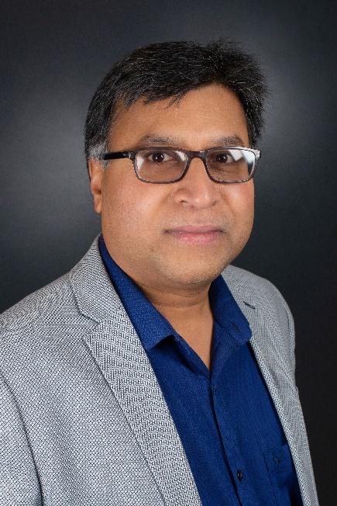
About the speaker: Dr. Choudhury is an Associate Professor in the Department of Chemistry at Missouri University of Science and Technology (Missouri S&T). His research focuses on inorganic solid-state and materials chemistry, with an emphasis on energy-related applications. He earned his BS and MS in Chemistry from the University of North Bengal, followed by a PhD in Solid-State and Materials Chemistry from the Indian Institute of Science, Bangalore. Dr. Choudhury then moved to Colorado State University as a postdoctoral fellow, where he worked on complex chalcogenides in the Dorhout Lab. In 2008, he joined Missouri S&T as an Assistant Research Professor in Chemistry. He was appointed a tenure-track Assistant Professor in 2011 and was promoted to Associate Professor in 2016.
Dr. Choudhury has published over 100 peer-reviewed journal articles. His research has been supported by funding from the NSF (SSMC-DMR), ACS-PRF, the UM Research Board, and various research centers at Missouri S&T. He is passionate about teaching at both the undergraduate and graduate levels. Dr. Choudhury has taught courses in physical and inorganic chemistry for undergraduate chemistry majors and has developed a graduate-level course on solid-state and materials chemistry.

