Prof. Michael W. W. Adams
Department of Biochemistry & Molecular Biology, University of Georgia, Athens, GA 30602

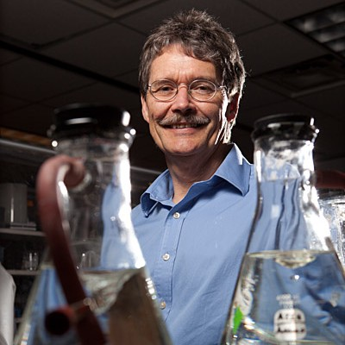

Title: Structure and Mechanism of a Diverse New Family of Electron Bifurcating Enzymes That Play Key Roles in Anaerobic Metabolism

Abstract: Microorganisms utilize electron bifurcating (BF-) enzymes to carry out thermodynamically unfavorable reactions. They reversibly couple an endergonic reaction (D → A, non-spontaneous) with an exergonic reaction (D → B, spontaneous) to generate a net reversible reaction (2D ↔ A + B) with minimal free energy change and maximal energy conservation. In such enzymes, the BF-site splits electron pairs from a mid-potential electron donor (D) and sends individual electrons down high potential and low potential pathways to reduce high (A) and low (B) potential acceptors. Electron bifurcation is now recognized as a major energy coupling system in biology. It has provided an explanation for some enigmatic reactions in microbial metabolism, including how NADH, a mid-potential donor, can be used to reduce the low potential iron-sulfur redox protein, ferredoxin. Ferredoxin oxidation drives many fundamental and global microbial processes, including methane production, hydrogen production, CO₂ fixation and nitrogen fixation. All electron bifurcating enzymes known use ferredoxin as one of the three redox active substrates and most of them use an unusual flavin to carry out electron bifurcation. In this presentation, I will describe the structural and catalytic properties of a large and diverse family of bifurcating enzymes, termed Bfu, that do not use the conventional BF-flavin and have a unique mechanism to bifurcate electrons. Moreover, the Bfu enzymes are surprisingly ubiquitous and are present in microbes not previously known to utilize bifurcation for energy coupling. Although only a few Bfu enzymes have been characterized, they are predicted to catalyze reactions involving an extensive range of substrates not hitherto thought to be involved in electron bifurcation reactions in anaerobic metabolism.

